Chapter 37 Study Guide
Communities and Ecosystems

1. Choose the most appropriate answer to match with each term
1. ___ habitat A. An interaction that directly benefits one species but does not harm or help the other
2. ___ community B. Has adverse effect on both of the interacting species
3. ___ commensalism C. The parasite benefits, the host is harmed
4. ___ mutualism D. The type of place one finds a particular organism;
characterized by physical features as well as other species
5. ___ interspecific E. The predator benefits, the prey is harmed
competition F. An interaction from which both species benefit
6. ___ predation G. The association of all populations of species in any
7. ___ parasitism given habitat
2. 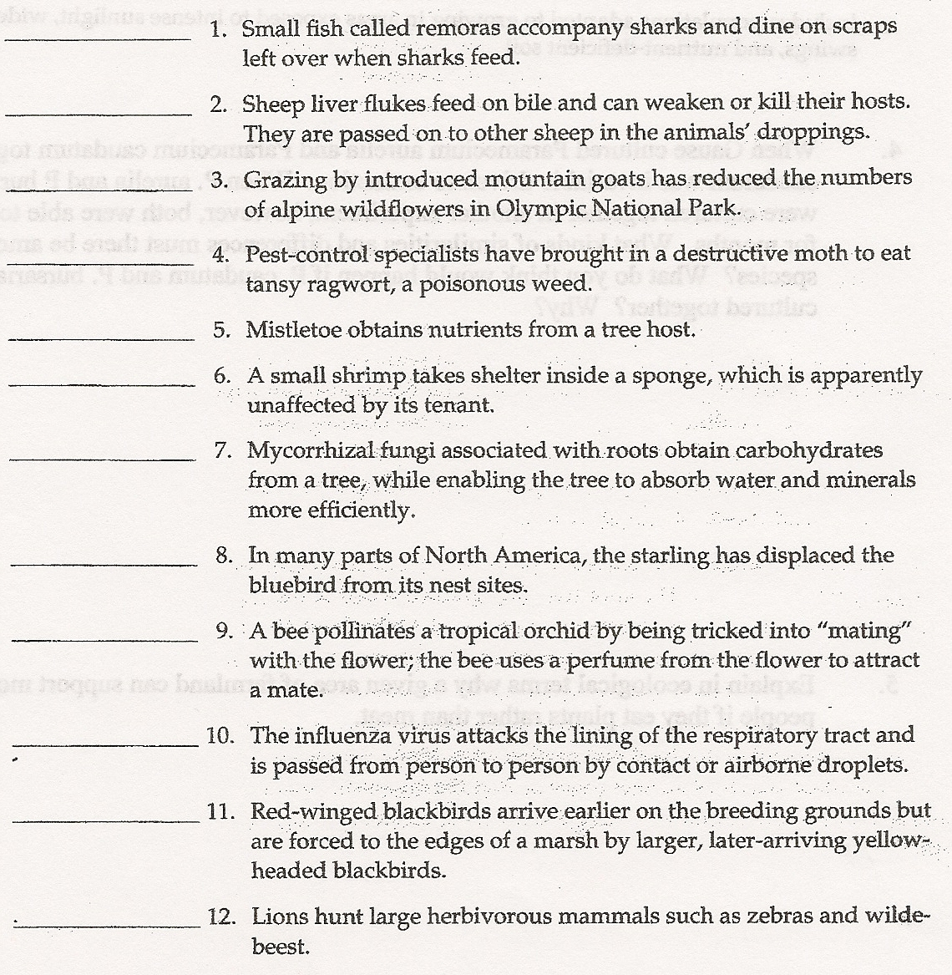

3. Identify each of the following as either
a. primary succession or b. secondary succession

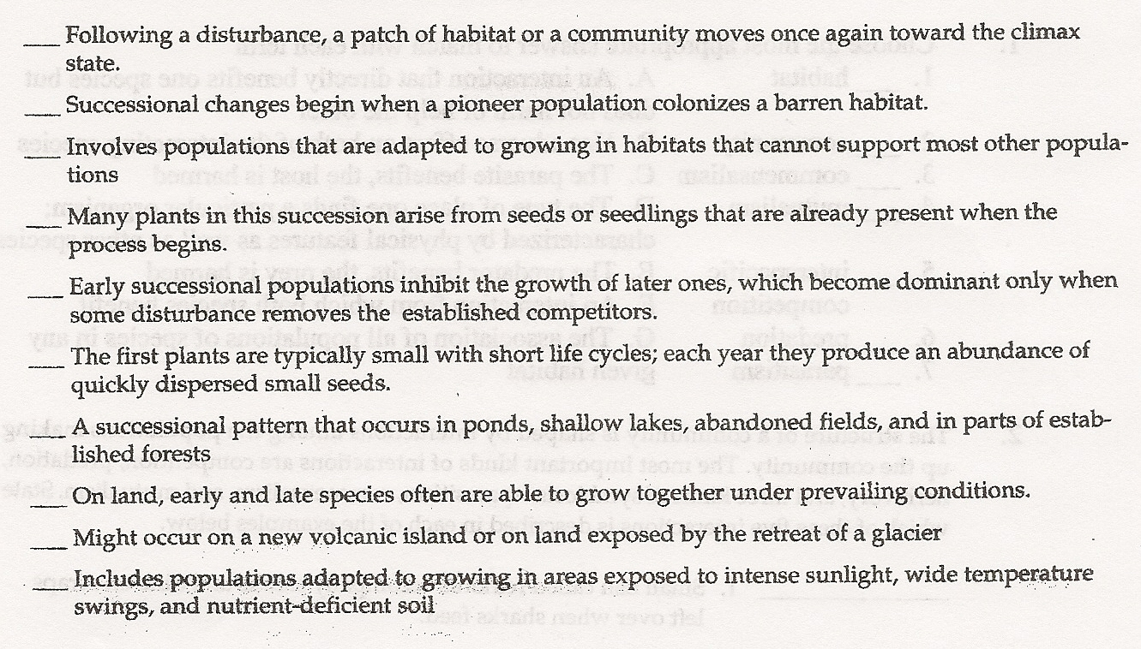

4 When Gause cultured Paramecium aurelia and Paramecium caudatum together, P. caudatum was invariable driven to extinction. When P. aurelia and P bursaria were cultured together in another experiment, however, both were able to coexist for months. What kinds of similarities and differences must there be among the 3 species? What do you think would happen if P. caudatum and P. bursaria were cultured together? Why?

5. Explain in ecological terms why a given area of farmland can support more people if they eat plants rather than meat.

6. What is decomposition? What are the two major kinds of decomposers in most ecosystems, and how is their role important to the ecosystem?

7. 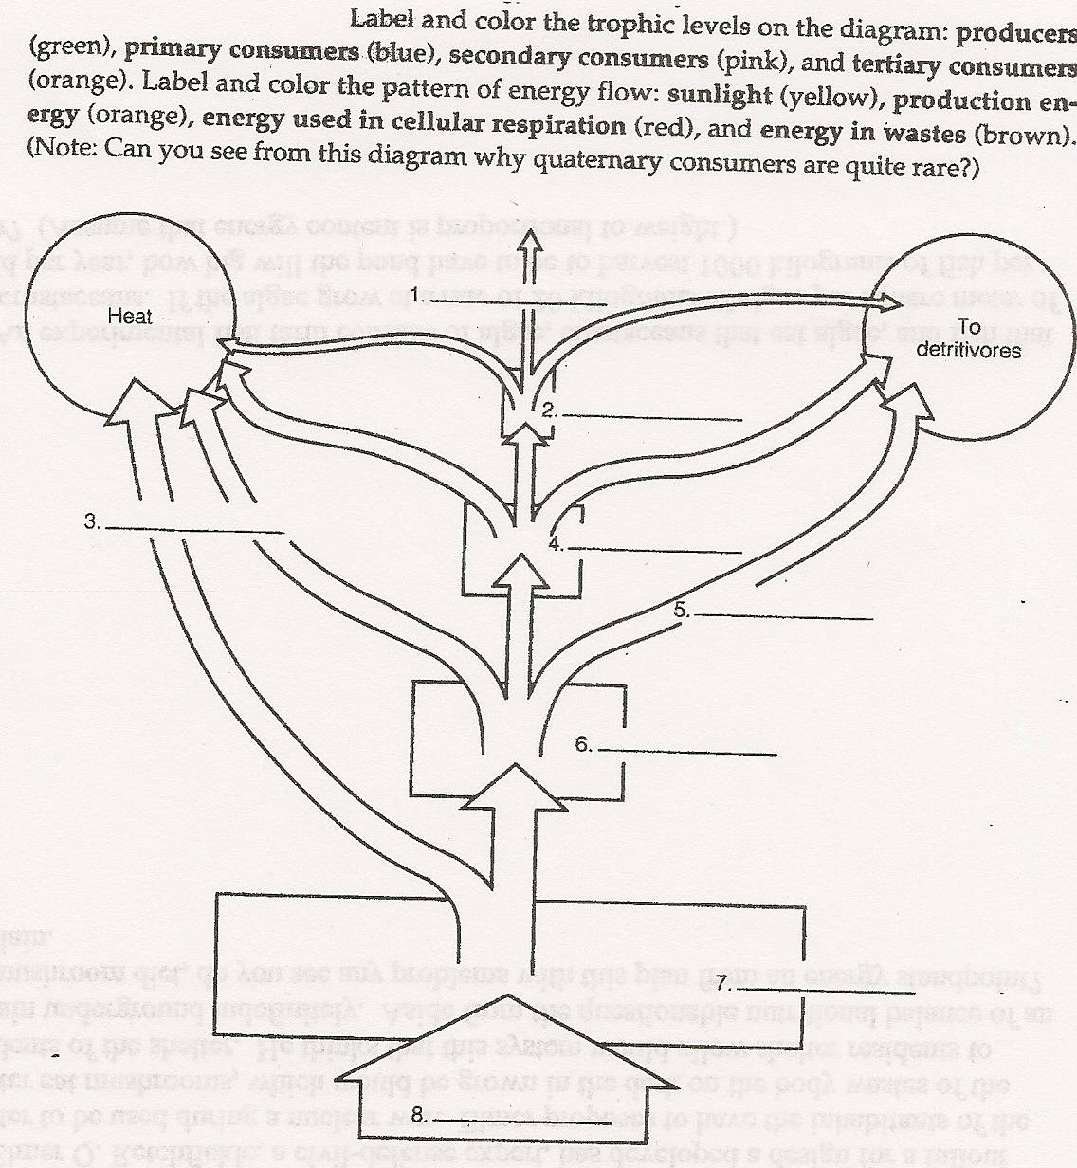

8. Elmer Q. Retchfickle, a civil-defense expert, has developed a design for a fallout shelter to be used during a nuclear war. Elmer proposes to have the inhabitants of the shelter eat mushrooms, which would be grown in the dark on the body wastes of the residents of the shelter. He thinks that this system would allow shelter residents to remain underground indefinitely. Aside from the questionable nutritional balance of an all-mushroom diet, do you see any problems with this plan from an energy standpoint? Explain.

9. An experimental fish farm consists of algae, crustaceans that eat algae, and fish that eat crustaceans. If the algae grow at a rate of 20 kilograms of algae per square meter of pond per year, how big will the pond have to be to harvest 1000 kilograms of fish per year? (Assume that energy content is proportional to weight.)

