Honors Biology Name:_________________________________________

Chemistry Review Homework

In Biology the most important molecule is dihydrogen monoxide (also known as water ). You already know that its chemical formula is H₂O.

Element | Protons (p⁺) | Neutrons (n⁰) | Electrons (e⁻) | Atomic mass units (amu)
Hydrogen
Oxygen

Based on this information, the mass of a water molecule = ___________________ amu.

The number of valence electrons is the same as the element’s group number in the periodic table. The further UP and to the RIGHT an element is in the table, the greater its electronegativity. Electronegativity is a measure of how strongly an element attracts electrons.

Element | Valence e⁻ | Lewis dot-diagram | Metal or nonmetal? | Electronegativity (look it up)
Hydrogen
Oxygen
Nitrogen
Sodium
Chlorine

A metal and non-metal atom form an ionic bond. The metal loses its valence electron(s) and becomes a cation, or positively charged ion. The non-metal gains electrons to make an octet, and becomes an anion, or negatively charged ion.

Draw the Lewis dot-diagram for the ionic compound Magnesium chloride (MgCl₂):
MgCl₂:

Two non-metals make a covalent bond. The atoms share and combine valence electrons to make an octet.

Element | Lewis dot-diagram | Methane (CH₄)
Carbon
Hydrogen

Neither Hydrogen nor Carbon have particularly high electronegativity values. Because their electronegativities are similar, Carbon and Hydrogen make a nonpolar covalent bond. When two non-metals have dissimilar electronegativities, i.e. one is high and one is low, they make a polar covalent bond.

Element | Lewis dot-diagram | Water (H₂O)
Oxygen
Hydrogen

Would these elements also make polar covalent bonds? (yes or no)

C-O__________ N-H__________ C-C__________ C-Cl__________ C-H__________

If a molecule contains polar covalent bonds, we assign the symbol δ- (partially negative) to the more electronegative atom, and δ+ (partially positive) to the less electronegative atom. Just as a negative ion is attracted to a positive ion, the δ- atom in one molecule is attracted to the δ+ atom in a different molecule. This attraction is known as a hydrogen bond.

CAUTION: HYDROGEN BONDS OCCUR BETWEEN MOLECULES, NEVER WITHIN A SINGLE MOLECULE.

Label the atoms forming hydrogen bonds δ+ or δ- in the nitrogenous bases:
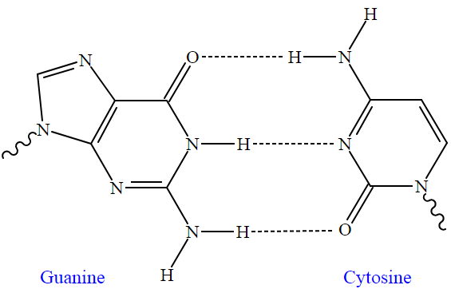
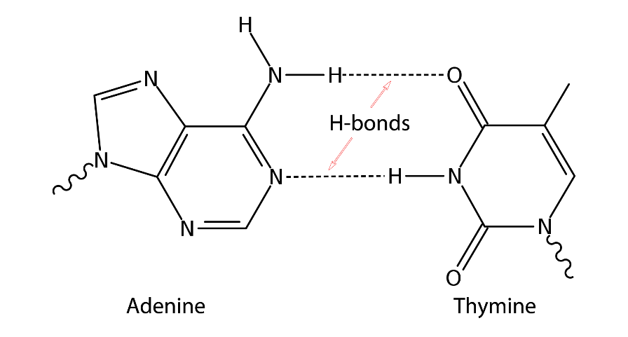

Before you finish, let’s review water’s special properties that result from its polar covalent bonds and hydrogen bonding between water molecules.

- H₂O molecules are cohesive; they form hydrogen bonds with each other.
- H₂O molecules are adhesive; they form hydrogen bonds with polar surfaces.
- Water has a high specific heat.
- Water’s polarity makes it a great solvent for polar and ionic compounds.
- Water’s greatest density occurs at 4 °C because of the space between water molecules h-bonded to each other.

Write in the letter (a, b, c, d, or e) that best explains the scenario. Some scenarios should be assigned more than one letter.

____ During the winter, air temperatures in the northern United States can remain below 0 °C for months; however, the fish and other animals living below the lakes survive.

____ Many substances—for example, salt (NaCl) and sucrose—dissolve quickly in water.

____ When you pour water in to a 25-mL graduated cylinder, a meniscus forms at the top of the water column.

____ Sweating helps reduce a human’s body temperature.

____ Water drops that fall on a surface tend to form rounded drops or beads.

____ If you touch the edge of a paper towel to a drop of colored water, the water will move up into (or be absorbed by) the towel.

